Maven Documentation

Maven is a build automation tool used primarily for Java projects. Maven is a popular open-source build tool developed by the Apache Group to build, publish, and deploy several projects at once for better project management.

Maven is a tool based on the concept of Project Object Model (POM). AProject Object Model or POM is the fundamental unit of work in Maven. It is an XML file that contains information n about the project and configuration details used by Maven to build the project.

Make sure java JDK is installed. Check using the following command:

* java --version

Install maven using the following command:

* unzip apache-maven-3.8.6-bin.zip

Verify the installation using:

* mvn -v

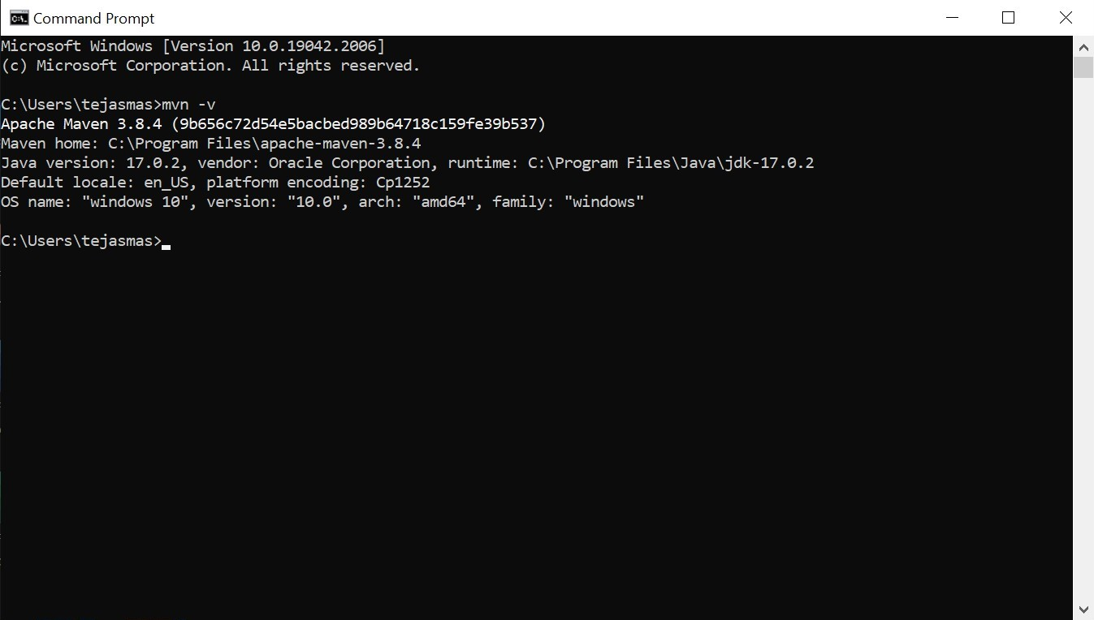

To show a demo, we will take an example project.

Create a directory and open cmd in that directory. Enter the following command to create a project.

* mvn archetype:generate -DgroupId=com.mycompany.app -DartifactId=my-app -DarchetypeArtifactId=maven-archetype-quickstart -DarchetypeVersion=1.4 -DinteractiveMode=false

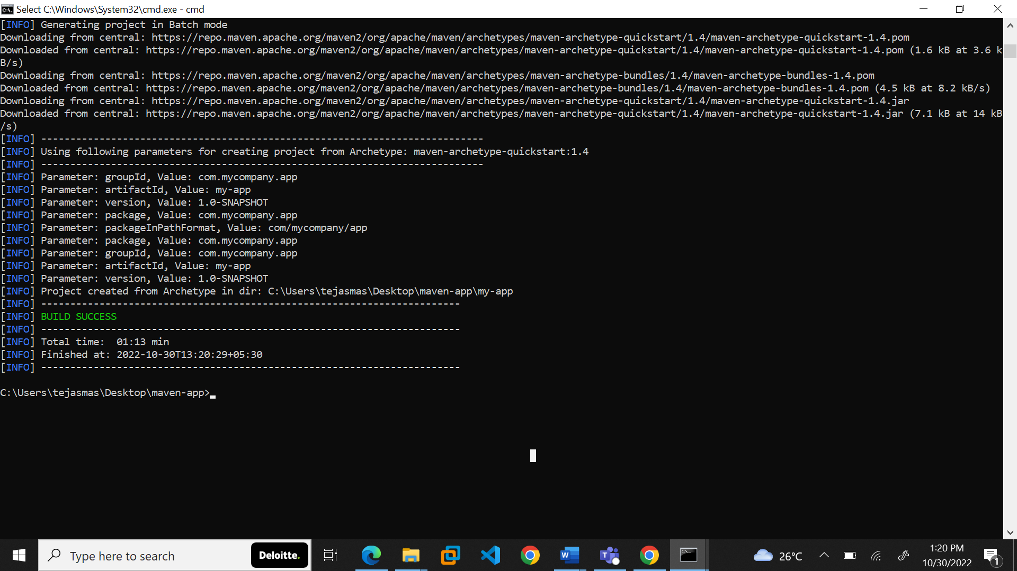

Open the project in any IDE of your choice.

Under src/main/java/com.mycompany.app/App.java contains the source code which prints out “My first maven app”.

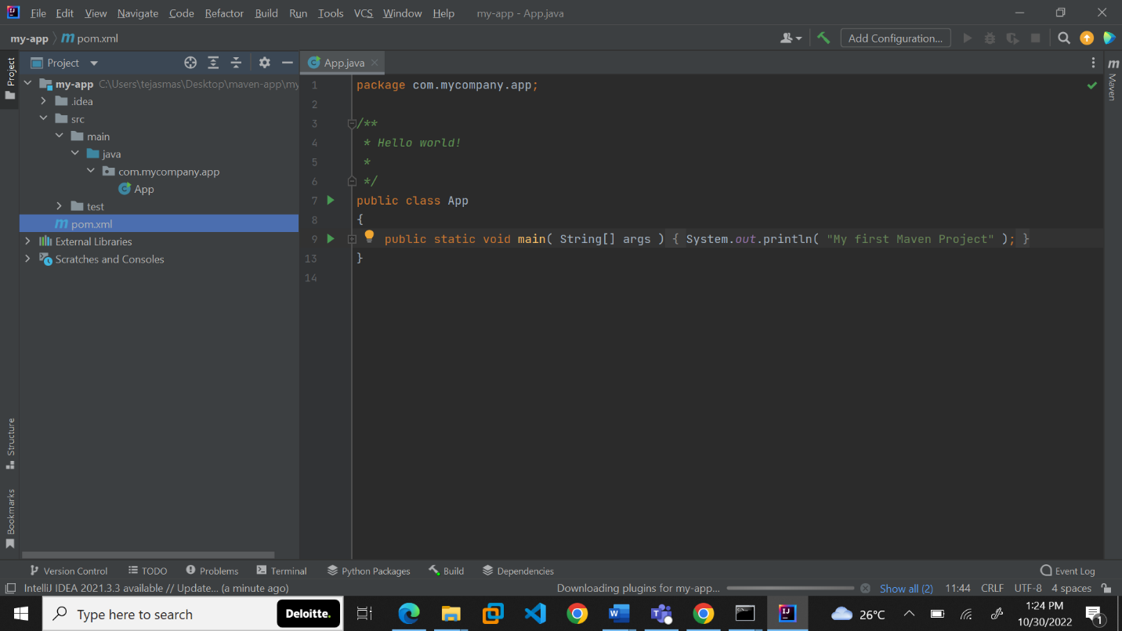

There we will be able to see the source code. The Project Object Model file is names as POM.xml.

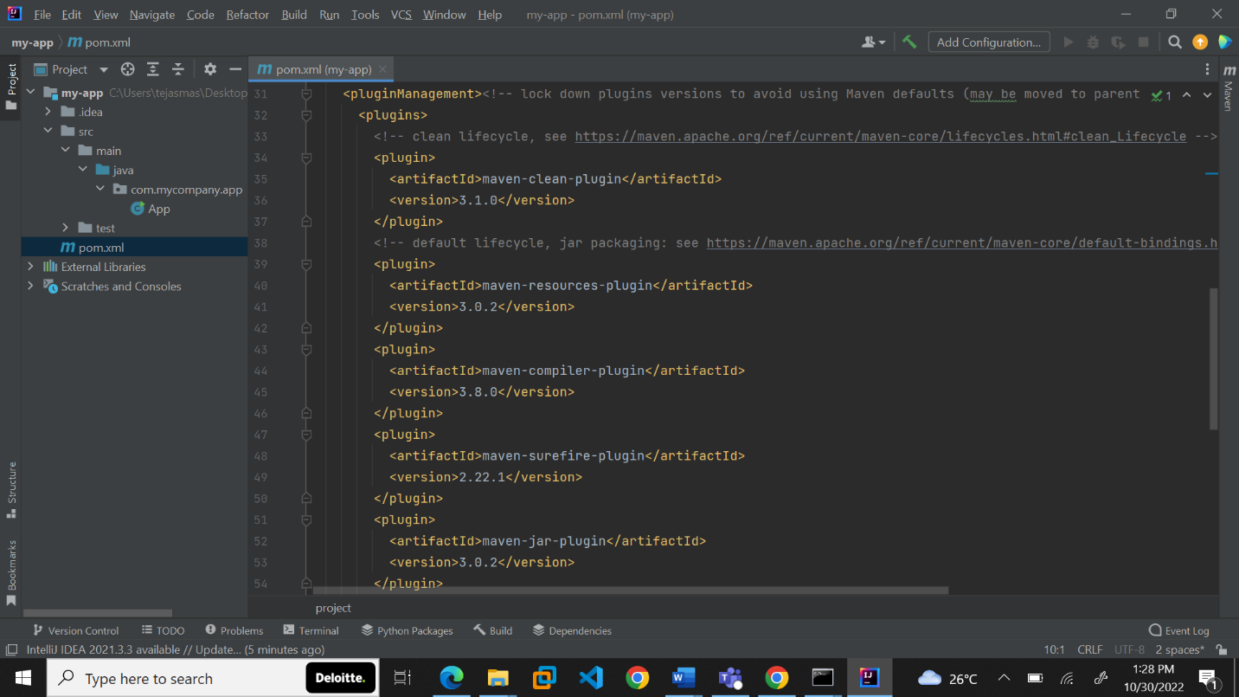

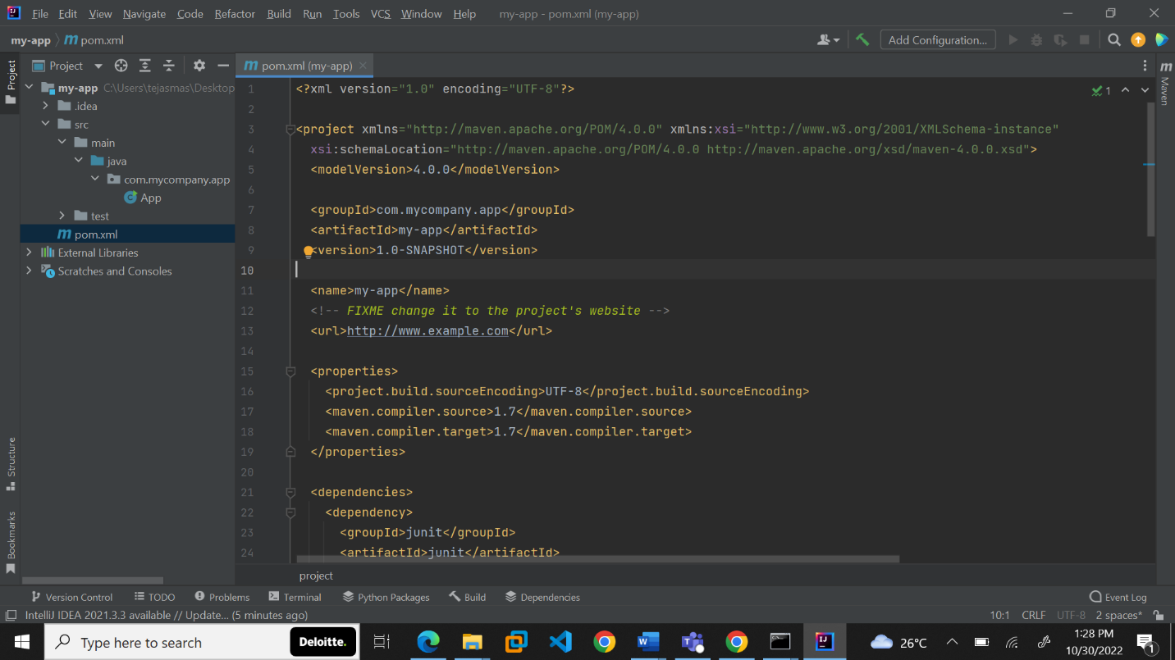

Next, we build the package using:

* mvn package : This command creates JAR or WAR file for the project to convert it into a distributable format.

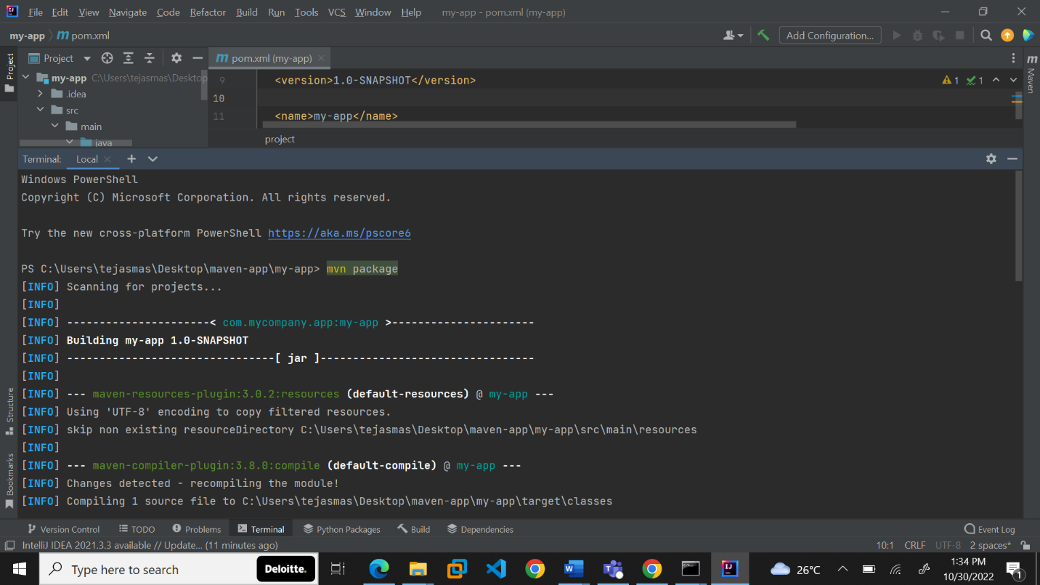

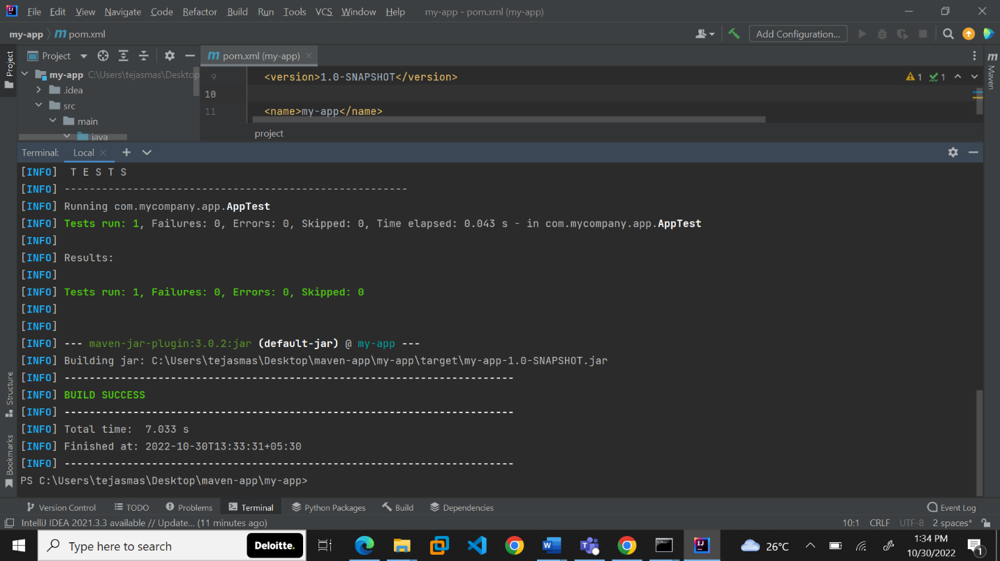

After building the maven package, we check the completely built package using the following command:

* mvn package

